**Vintage Large Carved Giltwood & Gesso Italian Wall Mirror**

**Price: $1285**

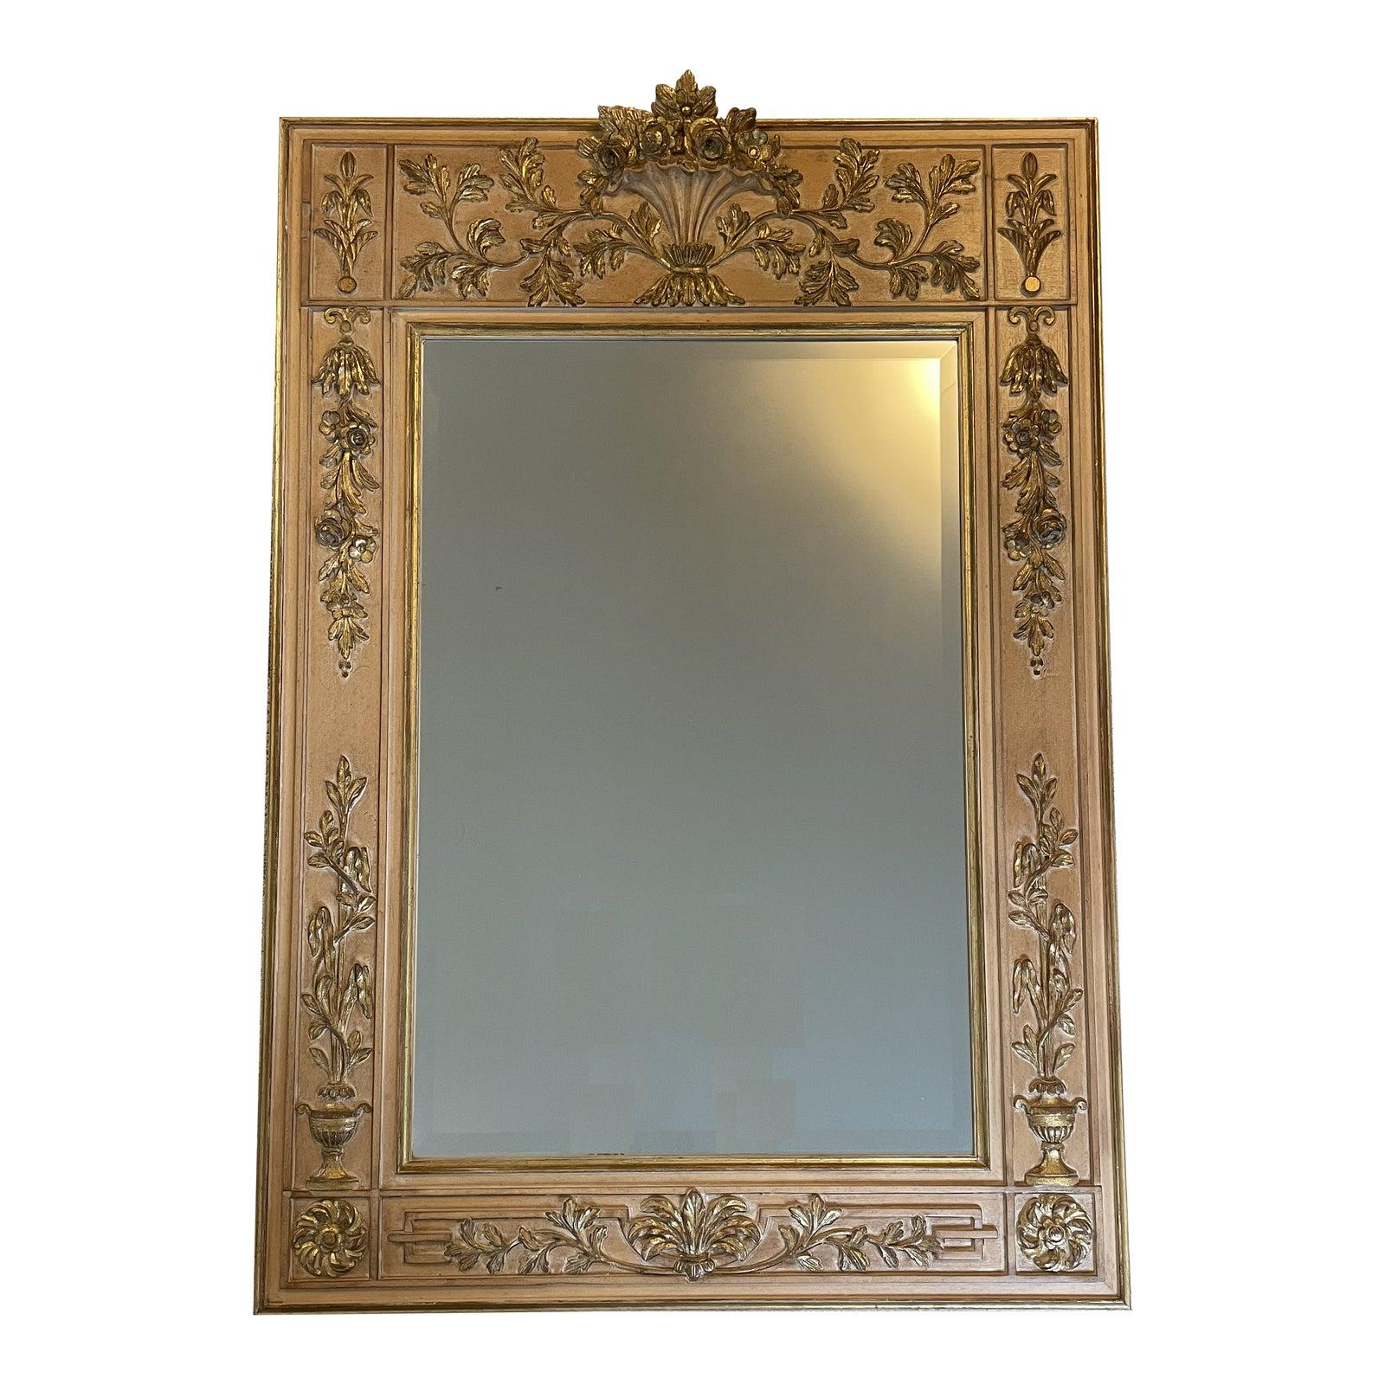

* CATEGORIES

Bathroom mirrors

* MATERIALS

Acrylic Bordered

* SHAPE

Rectangle

* BRAND

Viglacera